2200031128 CH BHAVANA
WEEK 8 TASK 1
Familiar with Git commands like git init, git status, git add, git commit, git push, and git pull.
In this hands-on lab, you will learn how to
- Setup your machine with Git Configuration
- Integrate notepad++.exe to Git and make it a default editor
- Add a file to source code repository
Prerequisites
- Install Git Bash client in your machine
Notes*:
Please follow the below steps for creating a free account in GitHub.
Don’t use cognizant credentials to login to GitHub.

Estimated time to complete this lab: 30 minutes.
Step 1: Setup your machine with Git Configuration
To create a new repository, signup with GitLab and register your credentials
Login to GitLab and create a “GitDemo” project
To check if Git client is installed properly: Open Git bash shell and execute
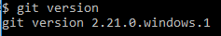
If output shows Git with its version information that indicates, that Git Client installs properly.
- To configure user level configuration of user ID and email ID execute
- To check if the configuration is properly set, execute the following command.
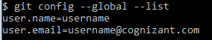

Step 2: Integrate notepad++.exe to Git and make it a default editor
- To check, if notepad++.exe execute from Git bash
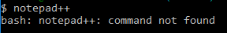
If Git bash could not able to recognize notepad++ command that implies notepad++.exe is note added to the environment path variable.

To add path of notepad++.exe to environment variable, go to control panel -> System -> Advanced System settings. Go to Advanced tab -> Environment variables -> Add path of notepad++.exe to the path user variable by clicking on “Edit”

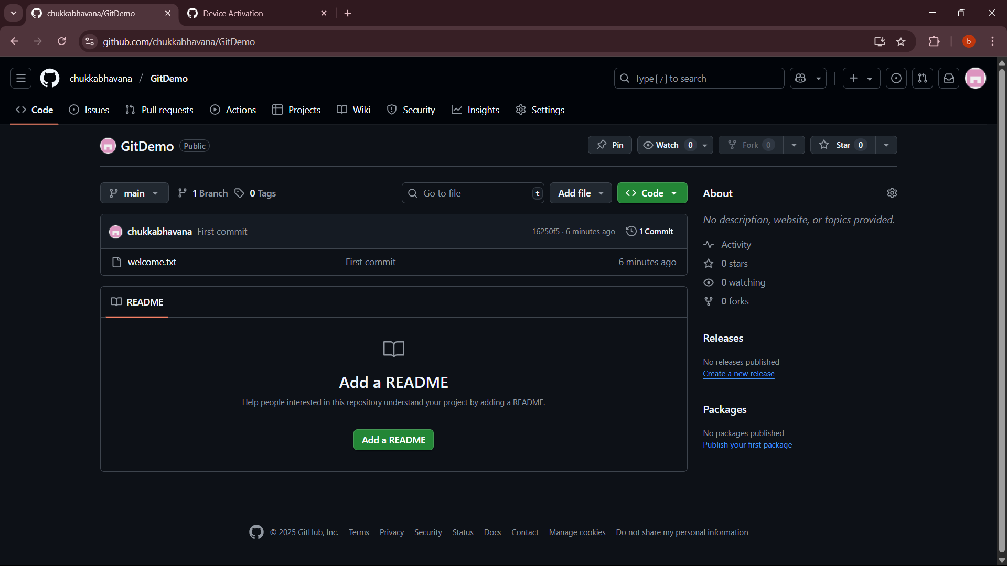
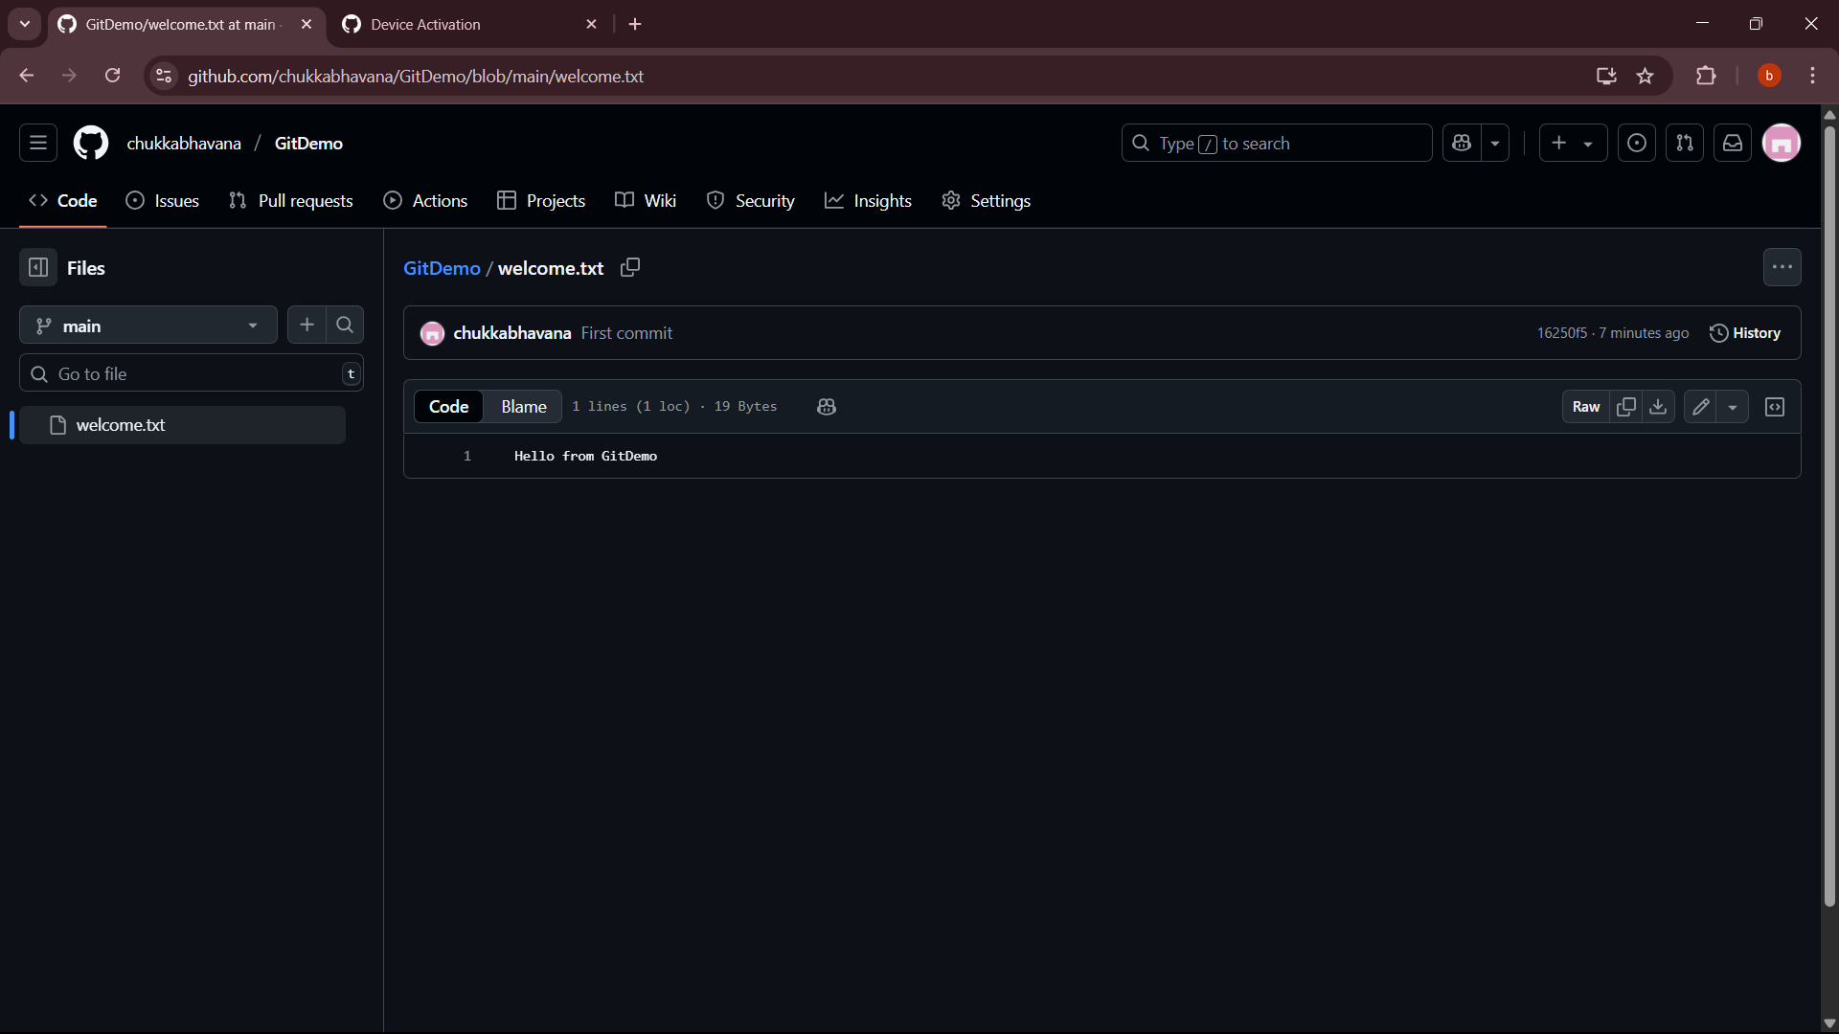
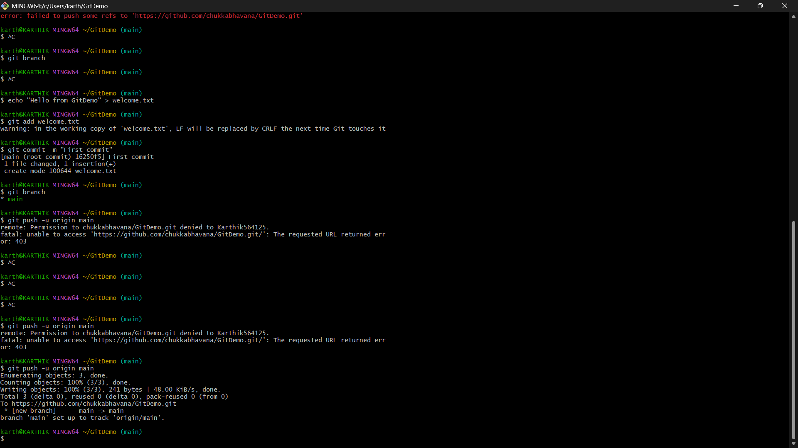

Step-by-step theory of the Git workflow
- git config --global user.name "..." / git config --global user.email "..."
  - Sets your identity stored in ~/.gitconfig.
  - Used as the author/committer information for every commit you create.
- mkdir GitDemo / cd GitDemo
  - Creates a working directory (your project workspace) and moves into it.
  - Files you create here are in the working directory (not yet tracked by Git).
- git init
  - Creates a .git/ directory — the Git repository metadata (objects, refs, config, index).
  - Before your first commit there is no branch ref yet. HEAD exists but doesn’t point at a commit until you commit.
- Create a file (e.g. echo "..." > welcome.txt)
  - Adds a file to the working directory. At this point it’s untracked.
- git status
  - Shows the state of the working directory and staging area (index): which files are untracked, modified, staged, etc.
- git add welcome.txt
  - Puts the file into the staging area (index).
  - Prepares those exact changes for the next commit. (Internally Git writes blob(s) and updates the index.)
- git commit -m "First commit"
  - Creates a commit object that records:
    - a snapshot of the staged tree,
    - metadata (author, committer, timestamp),
    - a commit message,
    - a pointer to parent commit(s) (none for the very first commit).
  - Also creates the branch ref (e.g., master or main) and moves HEAD to point at that commit. After this, the repository has history.
- git branch -M main
  - Renames your current branch to main (the -M forces the rename if needed).
  - Useful to match GitHub’s default branch name if required.
- git remote add origin https://...
  - Adds a remote repository entry named origin to your local repo configuration.
  - origin is just a conventional name for the remote you’ll push/pull to.
- git push -u origin main
  - Uploads your local commits to the remote origin, creating/updating origin/main.
  - -u (or --set-upstream) sets the local branch to track origin/main so future git push or git pull without arguments will default to that remote branch.
  - Authentication: with HTTPS you must authenticate (GitHub requires a Personal Access Token instead of password or use SSH keys). Permission errors (403) mean your authenticated user doesn't have write access.
- git pull vs git fetch
  - git fetch downloads commits from the remote into your local repo (but does not change your working tree).
  - git pull = git fetch + git merge (or rebase if configured). Use pull --rebase often to keep a linear history.
- Typical update cycle (the usual day-to-day flow)
  - Edit files in working directory.
  - git add <file(s)> (stage)
  - git commit -m "describe change" (record locally)
  - git push (send to remote)

